Renju lesson on May 9, 2002

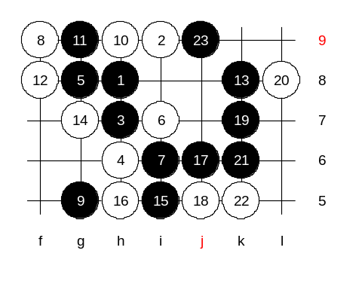
Hello everyone! Welcome to Online Renju Class. Today we will study about the alternative 5th move of our 4-h6-variant. Move 5-g8 is strong but not easy. Which one of you knows sure win here? Move 6-i7 is the only one we will look at. The other 6th moves are not so serious. Give me the first black moves, please. These 7 and 9 are traditional style. Black keeps the open space whenever possible. Basic rule - if no VCT, then we develop, by creating more power and block opponent's stuff at the same time. That is the purpose of the 9th move. We will quickly check some options here. Point h9 is powerful connection bridge for black, and white takes it first.
Where is black win move? Good. :) k8 indeed. Who wants to show the ending of attack, say ME.
good ASV :) thanks!

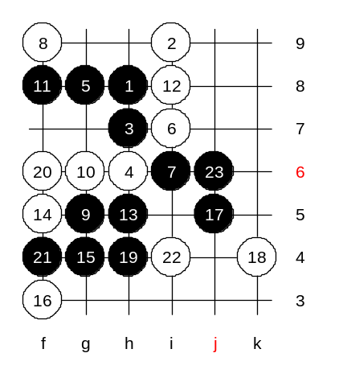

The variant becomes more interesting when white leaves the connections open and doesnt play to h9. Move 11-f8 is an important timing. By the 19th move, black has set up the final base for winning. Now black is unstoppable.

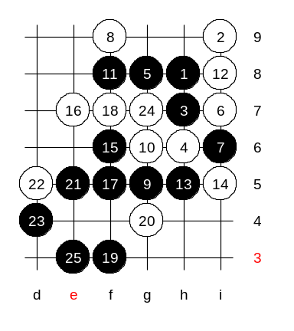

Another 14th move now. Do you know win? Say ME. :)
Good, thanks shadewawa!

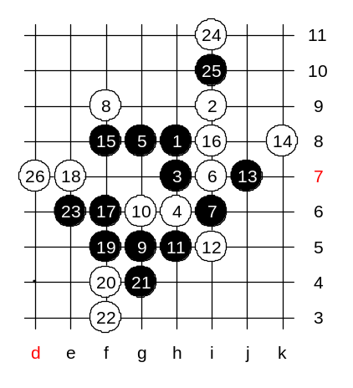

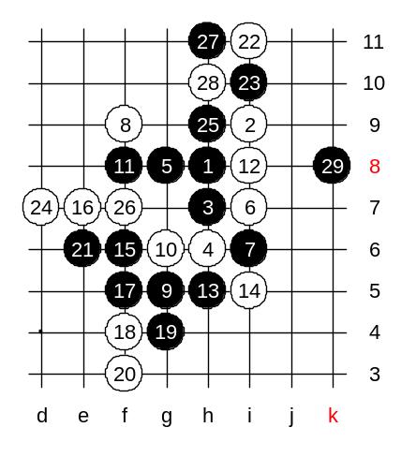
Hereby, I show you one example of a potential mistake that so many players often make. Those players attack logically, but appears to be wrong because of one small reason. So, far all logical, right? And suddenly no win! Black played a j7 in order to strengthen the position, which is maybe good in any other position in renju, but not here. As it seems now, black needed that k8 point. By playing the strengthening move earlier, black killed the connection with upper side.

Here black has the needed k8 point.

Move 10-f8 will be your homework. :)

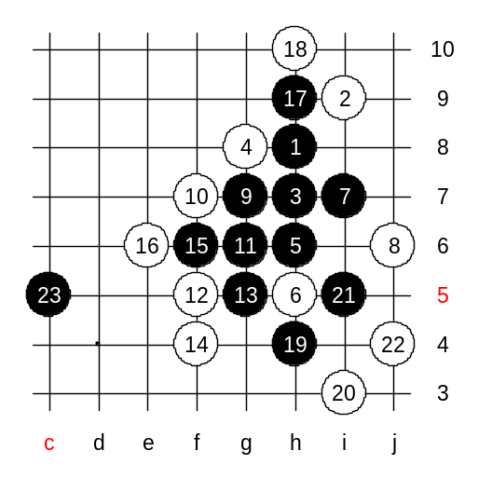
This 4th move is finished. Any questions? Say it now or hold your questions forever!! ;) Move 4-h9 is a headache. Let us leave it to the end. Ok? How about 4-g8? It is easy to learn because the 5-i8 leads to good old i6 opening. :)) Right? So, we only need to learn about 5-h6, and it will take just a few minutes.
Move 7, so natural. And correct. Move 8-j6 is the only strong move. However, black has at least two different ways to win after that. I think, as an advanced homework, you can dig out the VCT from the 9th move. VCT means, every move must be either three or four or VCF threat. You cannot use any pauses or waiting moves. So, now we will look at the second way of win, where black uses one pause. Move 11-g6 - a waiting move. That is the only moment where black needs such move. The rest of it is a VCT.
Over.

Although black win is effective, black used one pause in 11th move. Your homework will be to find another method for win, without any pauses at all, just continuous VCT.
The upper 6th move is a bit more complicated.
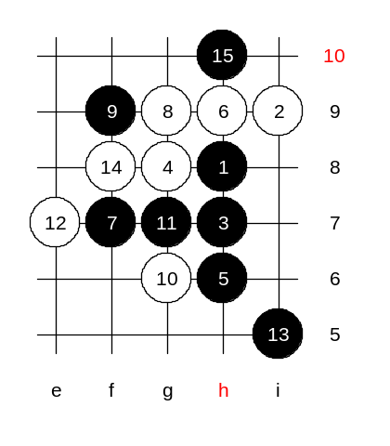
Black doesnt need a four yet, so 7-f7 is good enough. There are 14 moves on board. White has played its best moves so far. Black has a puzzle now, to block at h10 or play a four first. We all remember the rule, the four should be played only when its necessary. And, is it necessary now? Which one of them? In fact, I gave you simple question, but the answer is far from simple. I puzzled with this problem for some weeks in the past, until I made up my mind. Russian theory shows that both h4 and j4 should be played before h10, whereas Japanese theory doesnt play any fours at all. Interesting dilemma - who is right?! Long ago, in 5lin server, when we learned i6 opening, I gave this position for the students as a homework, having used the fours to h4 and j4 first. All the students studied for one week, and nobody came up with any answer. I could not believe it. I had thought there is a sure win by Russian theory without really checking it. So, after that failed homework, I took a closer look at that variant. I searched for 2 weeks without finding win. Indeed, my free time was limited, and my analysis was not so deep, but yet, I assumed if there was a win, it should have been an easy one. Japanese style goes without any fours, and they have a detailed analysis to prove their winning method. We have to check couple of different blocks here, but we will leave it for the next week. :)

